**NAMA : OSCA SAMUDERA CLEVER  
NIM : 2009076004  
METODE NUMERIK**

**Diketahui:**

Description: Image

Description: Image

Description: Image

**Penyelesaian:**

**v Gauss Naif**

Description: Image

Langkah:

· Description: Image

· Description: Image

· Description: Image

· Description: Image

Hasil:

Ø

Ø Description: Image

Description: Image

Image

Ø Description: Image

Description: Image

Image

Ø Description: Image

Description: Image

Description: Image

Image

**v Gauss Jordan**

Description: Image

Langkah:

*1) Description: Image*

*2) Description: Image*

*3) Description: Image*

*4) Description: Image*

*5) 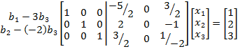*

Jadi: Description: Image

Description: Image

Description: Image